|  |  |
| --- | --- |
| Name | Vennila K R |
| Team ID | PNT2022TMID06140 |
| Project Name | Smart Solution For Railways |

# ASSIGNMENT 4

# Code:

#include <WiFi.h>

#include <PubSubClient.h>

#include <ArduinoJson.h>

WiFiClient wifiClient;

#define ORG "w85yph"

#define DEVICE_TYPE "b11m33e2devicetype"

#define DEVICE_ID "b11m33e2deviceid"

#define TOKEN "FK7jB&z3TSuS97sJ57"

#define speed 0.034

char server[] = ORG ".messaging.internetofthings.ibmcloud.com";

char publishTopic[] = "iot-2/evt/abcd_1/fmt/json";

char topic[] = "iot-2/cmd/home/fmt/String";

char authMethod[] = "use-token-auth";

char token[] = TOKEN;

char clientId[] = "d:" ORG ":" DEVICE_TYPE ":" DEVICE_ID;

PubSubClient client(server, 1883, wifiClient);

void publishData();

const int trigpin=18;

const int echopin=19;

String command;

String data="";

String lat="14.167589";

String lon="80.248510";

String name="point2";

String icon="";

long duration;

int dist;

void setup()

{

**Serial**.begin(115200);

pinMode(trigpin, OUTPUT);

pinMode(echopin, INPUT);

wifiConnect();

mqttConnect();

}

void loop() {

publishData();

delay(500);

if (!client.loop()) {

mqttConnect();

}

}

void wifiConnect() {

**Serial**.print("Connecting to "); **Serial**.print("Wifi");

WiFi.begin("Wokwi-GUEST", "", 6);

while (WiFi.status() != WL_CONNECTED) {

delay(500);

**Serial**.print(".");

}

**Serial**.print("WiFi connected, IP address: ");

**Serial**.println(WiFi.localIP());

}

void mqttConnect() {

if (!client.connected()) {

**Serial**.print("Reconnecting MQTT client to "); **Serial**.println(server);

while (!client.connect(clientId, authMethod, token)) {

**Serial**.print(".");

delay(1000);

}

initManagedDevice();

**Serial**.println();

}

}

void initManagedDevice() {

if (client.subscribe(topic)) {

**Serial**.println(client.subscribe(topic));

**Serial**.println("subscribe to cmd OK");

} else {

**Serial**.println("subscribe to cmd FAILED");

}

}

void publishData()

{

digitalWrite(trigpin,LOW);

digitalWrite(trigpin,HIGH);

delayMicroseconds(10);

digitalWrite(trigpin,LOW);

duration=pulseIn(echopin,HIGH);

dist=duration*speed/2;

if(dist<100){

dist=100-dist;

icon="fa-trash";

}else{

dist=0;

icon="fa-trash-o";

}

DynamicJsonDocument doc(1024);

String payload;

doc["Name"]=name;

doc["Latitude"]=lat;

doc["Longitude"]=lon;

doc["Icon"]=icon;

doc["FillPercent"]=dist;

serializeJson(doc, payload);

delay(3000);

**Serial**.print("\n");

**Serial**.print("Sending payload: ");

**Serial**.println(payload);

if (client.publish(publishTopic, (char*) payload.c_str())) {

**Serial**.println("Publish OK");

} else {

**Serial**.println("Publish FAILED");

}

}

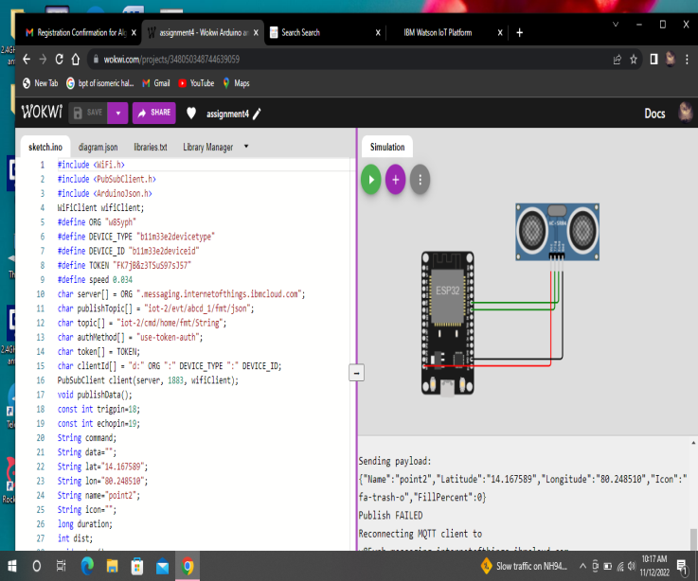

**IBM ALERT:**

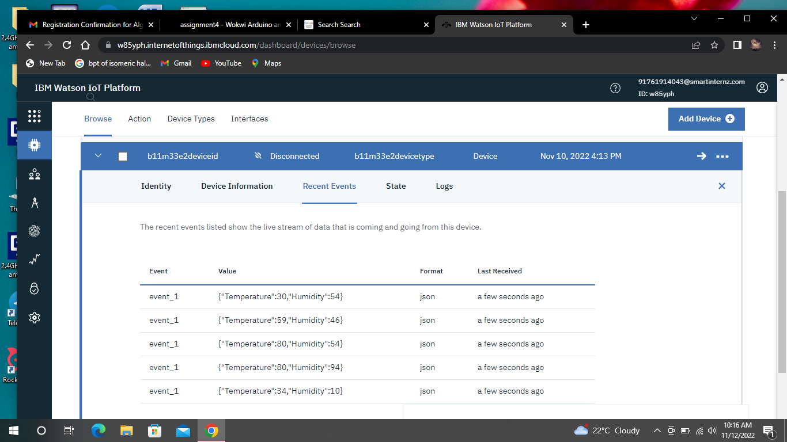

**LINK:**

https://wokwi.com/projects/348050348744639059